«Display_Name»
Computer Programming Using Kivy 1.9.0 - IGUI 3 - Dialog Box
GOAL: Make a window with a button that shows a dialog box and hides the first button.
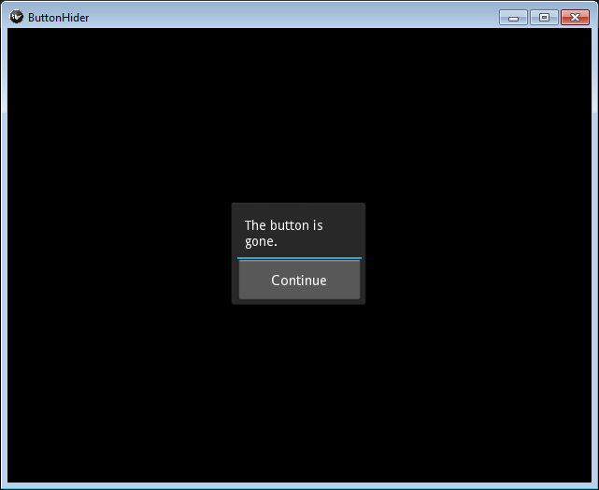
Making a new copy of kivy-boxlayout.py (so you don’t have to retype the code for making a Kivy App):
- Open Geany
- File, Open, then choose your igui-boxlayout.py (or File, New, then paste the code from IGUI 1 instructions)
- Make sure that the program runs 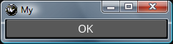 & looks exactly like the code in the IGUI 1 instructions
- File, Save As, Desktop, your home drive, then name it igui3dialog.py

Customizing the name of the App and text of the button:
- Both times MyApp is mentioned, change it to ButtonHider
- Change the button’s text from 'OK' to 'Show Dialog'

Creating an event:
- Program an event that shows a dialog with a Continue button (make the circled changes to your program—start with igui2 if you want the click binding already finished):
